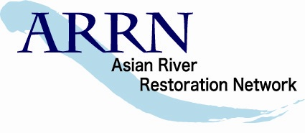 | Asian River Restoration Network  http://www.a-rr.net/
Planning Division  Foundation for Riverfront Improvement and Restoration (RFC)  Lofty Chuoh Bldg., 7th Flr., 17-24, Shinkawa 1cho-me, Chuo-ku, Tokyo 104-0033, JAPAN |  | Phone:  Fax:  Email: | +81-3-6228-3860  +81-3-3523-0640  secre@a-rr.net

Membership Application ( for Organization Member)

Joining the ARRN is Free!
To become member of ARRN, please read the following instruction, and send a membership application form to secre@a-rr.net by email.

Membership Benefits

- Easy obtaining of domestic and foreign information on river restoration through website, email, and direct contact to ARRN secretariat or other ARRN members as following;
  - Latest news, topics, projects, experiences, lessons, case studies
  - International and domestic events such as seminar and workshops
  - Standard books, technical guidelines, video images, etc.
- Holding opportunity to introduce member’s organization and their activities to other ARRN members
- A coordinated business with various foreign countries or organizations
- Holding management support such as international seminar, workshops and establishment of regional river restoration network by ARRN secretariat

Possible Tasks

- Members will participate in ARRN with commitment to use their own resources and to work effectively in partnership with other members that are collaborating in the network. Members will support the objectives of ARRN described in the charter. ( http://www.a-rr.net/charter.html )
- Members can freely inspect the Web site, and moreover, useful information on river restoration in your organization and your region can be freely sent through the Web site for other members.
- Members positively join for ARRN events such as international forum and the workshop by each RRN sponsoring. Also, every member can hold original workshop by receiving the backup of ARRN or RRN.
- Members cooperate positively when the specialist's technical advice is required or the advanced case investigation committee is sent to another region.
- Members share the information sent by ARRN with related persons in your organization.

Procedure for joining ARRN

(1) An organization which wants to join ARRN is requested to submit a membership application form by email. (Attached the following page)
(2) The membership application form submitted by the organization is judged by the Secretary General and the Chairperson of ARRN.
(3) After the Chairperson of ARRN approves the membership application form, the organization becomes the ARRN member as a Non-RRN organization. (Refer to the following ARRN Organizational Structure)
(4) ARRN secretariat will send email soon to the contact person named in the application form.
(5) When plural groups gathered in a certain country or regions, the ARRN secretariat supports the establishment of each RRN. The establishment of new RRN will be judged by ARRN governing council meeting.

Note)
In a country/region which RRN secretariat has already established, applicants to ARRN should be registered through the RRN secretariat. (China, Korea, and Japan)
For further information, please contact to secre@a-rr.net by email.

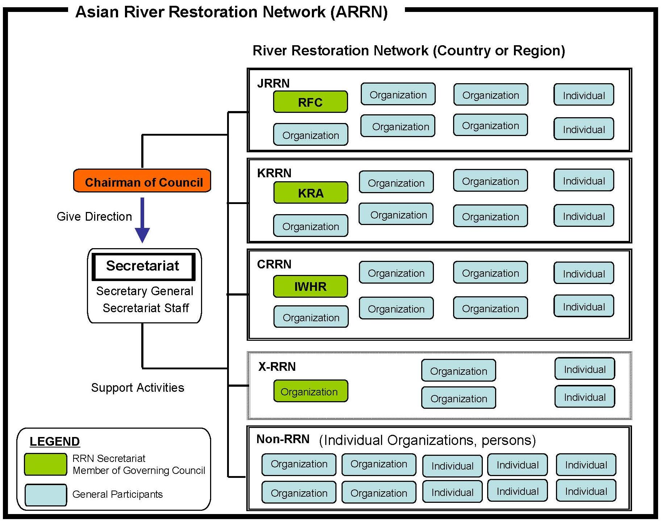
ARRN Organizational Structure

Asian River Restoration Network
http://www.a-rr.net/
Planning Division  Foundation for Riverfront Improvement and Restoration (RFC)  Lofty Chuoh Bldg., 7th Flr., 17-24, Shinkawa 1cho-me, Chuo-ku, Tokyo 104-0033, JAPAN |  | Phone:  Fax:  Email: | +81-3-6228-3860  +81-3-3523-0640  secre@a-rr.net

Membership Application Form (for Organization Member)

To become member of ARRN, please fill in the following form and send it to secre@a-rr.net by email.

(Organization Information)
Name of Organization :
Country or Region :
URL : http://

(Representative Information)
Name of Representative : (Dr. / Mr. / Ms.)
(First Name) (Surname)
Position :

(Contact Person Information)
Name of Contact Person : (Dr. / Mr. / Ms.)
(First Name) (Surname)
Position :
Address :
Town / City :
Country : Postcode :
Telephone : Fax :
Email :

(Other Information, if any)

Asian River Restoration Network
http://www.a-rr.net/
Planning Division  Foundation for Riverfront Improvement and Restoration (RFC)  Lofty Chuoh Bldg., 7th Flr., 17-24, Shinkawa 1cho-me, Chuo-ku, Tokyo 104-0033, JAPAN |  | Phone:  Fax:  Email: | +81-3-6228-3860  +81-3-3523-0640  secre@a-rr.net

Membership Application Form (for Organization Member)

To become member of ARRN, please fill in the following form and send it to secre@a-rr.net by email.

(Organization Information)
Name of Organization : Foundation for Riverfront Improvement and Restoration .
Country or Region : JAPAN
URL : http://www.rfc.or.jp/english/top.htm
SAMPLE
(Representative Information)
Name of Representative : (Dr. / Mr. / Ms.) Koutarou Takemura
(First Name) (Surname)
Position : President

(Contact Person Information)
Name of Contact Person : (Dr. / Mr. / Ms.) Taro Riverfront
(First Name) (Surname)
Position : Technical Coordination & Cooperation Division
Address : Ichibancho FS Bldg. , 8 Ichibancho, Chiyoda-ku
Town / City : Tokyo
Country : JAPAN Postcode : 102-0082
Telephone : +81-3-3265-7121 Fax : +81-3-3265-7456
Email : secre@a-rr.net

(Other Information, if any)

