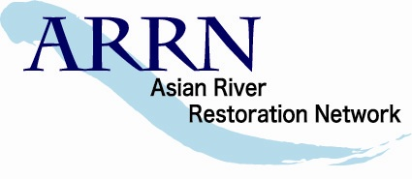 | Asian River Restoration Network  http://www.a-rr.net/
Japan River Restoration Network (JRRN) secretariat  Japan Riverfront Research Center (RFC)  NMF Kayabacho Bldg., 7th Flr. 17-24, Shinkawa 1cho-me, Chuo-ku, Tokyo 104-0033, JAPAN |  | Phone:  Fax:  Email: | +81-3-6228-3865  +81-3-3523-0640  secre@a-rr.net

ARRN Membership Application Form ( for Non RRN -organization )
To become member of ARRN, please fill in the following form and send it to secre@a-rr.net by email.
(Profile of Organization)
Name of Organization:
URL: http://
Name of Representative: (Dr. / Mr. / Ms.)
(First Name) (Surname)
Position of Representative:
Field and Outline of Activity:

(Contact Information)
Name of Contact Person: (Dr. / Mr. / Ms.)
(First Name) (Surname)
Position of Contact Person:
Address:

Telephone: Fax:
Email:
(Other Information, if any)

